[**VISUAL PHYSICS ONLINE**](http://www.physics.usyd.edu.au/teach_res/hsp/sp/spHome.htm)

**MODULE 6 ELECTROMAGNETISM**

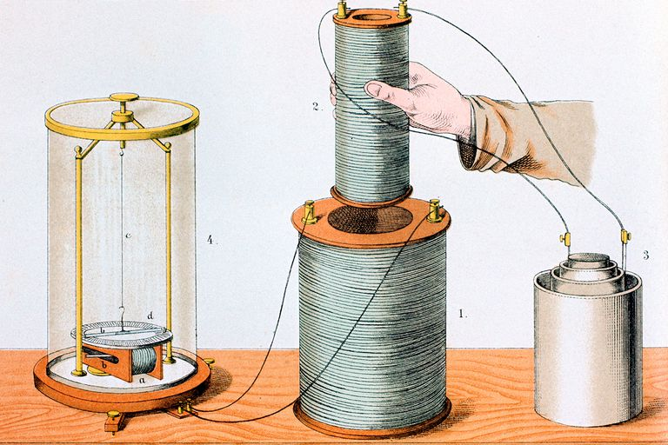

**ELECTROMAMAGNETIC INDUCTION**

|  |
| --- |
| **Magnetic flux**  **Faraday’s law of electromagnetic induction**  • A changing magnetic field induces a changing electric field.  • A changing magnetic flux induces a changing electric field  • The changing electric field induces an emf in a conductor.  • In a conductor loop, the changing emf induces a current.  **emf induced in a moving conductor**    *B* is constant and *B*, *L* and *v* are mutually perpendicular  **Lenz’s Law** is a consequence of the law of conservation of energy – the induced emf and induced current are in such a direction as to oppose the change that produces them. |

**TWO MEN WHO CHANGED OUR WORLD**

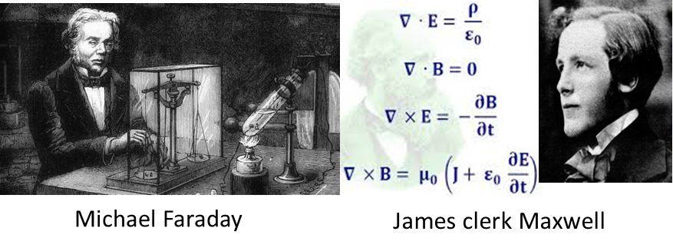

|  |
| --- |
| **Exercise**  Do a web search to investigate the life and work of Faraday and Maxwell.  Consider the images below. Make a list of the differences in the two worlds and consider the work of Faraday and Maxwell. |



English **Michael Faraday** (1791 – 1867) who experimented with electric and magnetic phenomena discovered that a changing magnetic field produces an induced emf (voltage – source of electrical energy). **Faraday’s law of electromagnetic induction** is one of the great laws of physics. This phenomenon is the basis for many practical devices such as transformers, reading computer memory, electronic devises, alternators and generators. Without generators, we could not produce large quantities of electrical energy required for our modern society to function.

**MAGNETIC FLUX Φ*B* [T.m-2 ≡ W webber]**

A useful quantity is to consider the number of magnetic field lines crossing an area. This concept is called the **magnetic flux** and is illustrated and defined in figure 1.



Fig. 1. Magnetic flux when the magnetic field B is uniform over an area A.

**FARADAY’S LAW – ELECTROMAGNETIC INDCTION**

• A changing magnetic field induces a changing electric field.

• A changing magnetic flux induces a changing electric field

• The changing electric field induces an emf in a conductor.

• In a conductor loop, the changing emf induces a current.

The above processes are known as **electromagnetic induction**.

**Lenz’s law** – the induced emf and induced current are in such a direction as to oppose the change that produces them.

**Faraday’s law** is expressed mathematically by equation 1.

(1A) 

induced emf  [ V ]

magnetic flux  [ weber Wb or T.m-2 ]

change in magnetic flux  [ Wb or T.m-2 ]

small time interval  [ s ]

- the negative sign gives the direction of the induced emf

More formally, Faraday’s law is

(1B) 

The induced emf is equal to the negative of the time rate of change of the magnetic flux.

|  |
| --- |
| **Predict Observe Explain**  Write and sketch **your predictions** for a permanent magnet passing through a solenoid (coil):   * How do the forces on the permanent magnet change as the magnet enters and exits the solenoid? * How does the current in the solenoid change as the magnet passes through it? * Sketch a graph of the current vs time as the magnet passes through the solenoid. * How do Faraday’s law and Lenz’s law apply to this situation.   **Observe** the animation of the permanent magnet as it passes through the coil windings of the solenoid. Use the right-hand screw rule to verify the directions of the induced magnetic fields shown in the animation.  **Explain** Compare your predictions with your observations, and explain any discrepancies.  [Image2](http://www.physics.usyd.edu.au/teach_res/hsp/u6/emf_1.htm) View the animation |

The magnetic flux through a circuit can be changed in many ways:

* Increasing the current through a coil will increase the magnetic field surrounding it.
* A permanent magnetic maybe moved toward or away from a circuit.
* The circuit itself maybe moved toward or away from a magnet.
* The orientation of a coil in a magnetic field can be changed.

In every case, the induced emf is given by the rate of change of the magnetic flux and the direction of the emf can be determined by applying Lenz’s Law.

When the magnetic field through a conductive loop is increasing, an electric field is induced which produced an induced emf and a resulting induced current. **The emf is distributed throughout the loop** (there is no positive or negative terminals to drive the current as in the emf of a battery). The direction of the electric field, induced emf and induced current are determined by using Lenz’s law and the right-hand screw rule (curl of fingers – current: thumb – direction of induced magnetic field) as shown in figure 2.

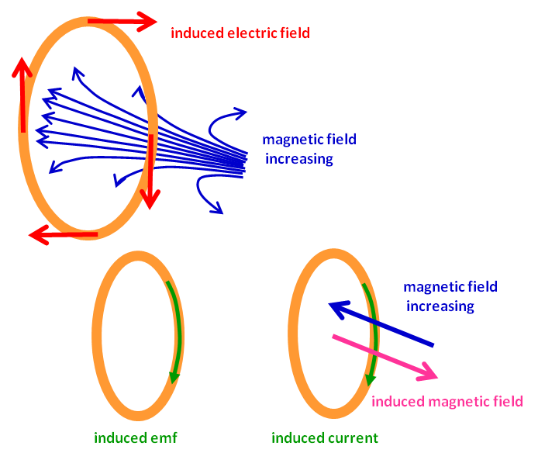

Fig. 2. Changing magnetic flux through a coil. Lenz’s Law: the direction of the current induced in a conductor by a changing magnetic field is such that the magnetic field created by the induced current opposes the initial changing magnetic field. Explains the direction of many effects in electromagnetism: direction of voltage induced in an inductor or wire loop by a changing current, or the drag force of eddy currents exerted on moving objects in a magnetic field.

Faraday experimented with a Faraday ring as shown in figure 3. A changing magnetic flux in the iron ring induced a current in the galvanometer coil. The changing magnetic flux is produced only when the switch is opened or closed. There is no deflection of the galvanometer pointer when a steady current is flowing in the coil on the left.

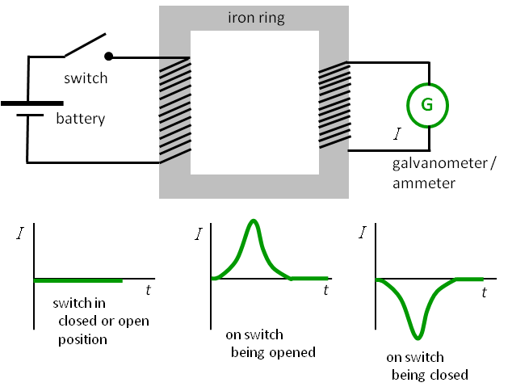

Fig. 3. Faraday’s ring.

Two coils are placed on top of each other as shown in figure 4. The lower coil (P) has a changing current through it. The upper coil (S) has a current induced in it because of the changing magnetic flux produced by the changing current in coil P. The direction of the induced magnetic field and induced current for coil S is determined by Lenz’s law and the right-hand screw rule.

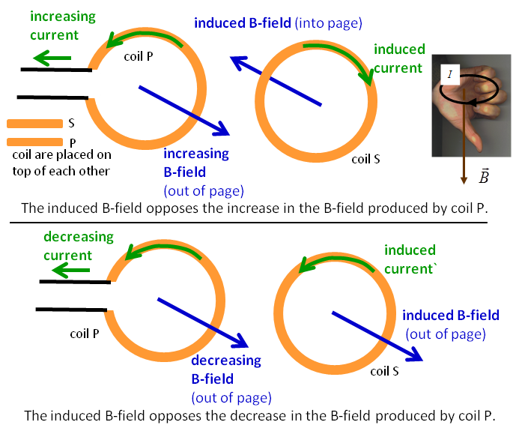

Fig. 4. The coils placed on top of each other.

|  |
| --- |
| Why do you often observe sparks when a plug is pulled out of a power point?  When the plug is pulled quickly away from a power point socket when turned on, the current abruptly drops to zero and the magnetic field due to the current collapses. This changing magnetic flux produces an emf that tries to maintain the original current, resulting in a spark at the terminals of the plug and socket. |

**LENZ’S LAW**

**Lenz’s law is a consequence of the law of conservation of energy**.

Consider what would happen when a permanent magnet is pushed towards a conductive coil. According to Lenz’s law a current is induced in the coil which induces a magnetic field that interacts with the B-field of the magnet to oppose the motion towards it.

What happens if Lenz’s law was not true? Then, the induced current would create a magnetic field to attract the magnet. The permanent magnet under the action of this attractive force would accelerate and increase its speed and kinetic energy. But, the greater the speed the greater the change in magnetic flux and hence the induced current would increase and the greater the attractive force. The current would continually grow indefinitely and the kinetic energy of the magnet would also increase indefinitely – this would be a violation of the law of conservation of energy.

**emf INDUCED IN A MOVING CONDUCTOR**

Consider a straight conductor of length *L* moving through a uniform magnetic field *B* as shown in figure 5. The conductor is moving with a speed *v* and travels a distance  in the time interval . The area swept out by the conductor in transgressing the B-field is . Therefore, there will be a changing magnetic flux and an emf induced in the conductor. This is often referred to as a **motional emf**. By Faraday’s law, the magnitude of the induced emf  across the end of the conductor is given by

(2) 

This equation is valid provided *B* is constant and *B*, *L* and *v* are mutually perpendicular.

The direction of the induced emf is determined by Lenz’s rule and the right-hand palm rule. The force on the electrons in the moving conductor is up which causes a charge separation: the top of the conductor becomes negative while the bottom of the conductor becomes positive.



Fig. 5. A conductor moving through a uniform B-field. The direction of the magnetic force on a positive charge would be down the page. Hence the charge on an electron is up the page.

When there is a complete circuit, the induced emf will give a current. For the arrangement shown in figure 6, the direction of the induced current is clockwise. The induced emf drives the current through the complete circuit. The conductor carrying the current in the magnetic field will experience a force to oppose its motion (right-hand palm rule). As the conductor moves to the right, the area swept out increase, so the magnetic flux increases. By Lenz’s law, the induced current must produce a magnetic field to oppose the change, so the induced magnetic field must be into the page, therefore, the current must be in a clockwise direction.



Fig. 6. A conductor sliding on conductive rails through a uniform magnetic field.

Thus, when a conductor moves in a magnetic field it acts as a source of electrical energy. This is the basis of a **generator**.

|  |
| --- |
| **Example**  Consider the conductor length *L* moving at a constant velocity *v* of through a region of uniform magnetic field as shown in figure 6. The parameters are:  *B* = 0. 555 T *v* = 6.23 m.s-1 *L* = 125 mm *R* = 10.2 Ω  Calculate the following (assume negligible resistance for conductor & rails and the conductor moves at a constant speed):  Induced emf  Inducted electric field in the conductor *E*  Current in the circuit  External applied force acting on the conductor *F*  Power dissipated in the resistor *P*    **Solution**  How to approach the problem   * Re-draw the diagram and annotate it with the unknown and unknown data. * Type of problem: conductor moving through a magnetic field / circuits. * Knowledge – equations   Faraday’s law  (uniform B-field)  Electric field and potential difference  Ohm’s law  Force on a conductor  (uniform B-field)  Power dissipated in a resistor  or  Knowns  *B* = 0. 555 T *v* = 6.23 m.s-1 *L* = 125x10-3 m *R* = 10.2 Ω  Unknowns  = ? V *E* = ? V.m-1  = ? A *F* = ? N *P* = ? W |

|  |
| --- |
| **THINKING EXERCISE**  *A picture is worth a 1000 words*. Study the pictures below and commit them to your memory. For each picture, what physics story does it tell? |

[View online video](https://www.youtube.com/watch?v=jeTmIa00_rc)

[YouTube Video: Electromagnetic Induction & Superconductors](https://www.youtube.com/watch?v=zPqEEZa2Gis)

(can you find the mistake in one of the diagrams?)

[VISUAL PHYSICS ONLINE](http://www.physics.usyd.edu.au/teach_res/hsp/sp/spHome.htm)

If you have any feedback, comments, suggestions or corrections please email:

ian.cooper@sydney.edu.au